# **EEE4118F - Process Control & Instrumentation**

# **Lab Report – Part A: System Identification**



|  |  |  |  |  |
| --- | --- | --- | --- | --- |
|  | Names | Student Number | Date of the practical | Station Number |
| Student 1 | Shaun Labuschagne | LBSSHA005 | 01/03/2022 | 6 |
| Student 2 | Sarah Tallack | TLLSAR002 |

# Contents

1. System description 3

1.1 Equipment and connection description: 3

1.2 Equipment in control loop diagram (open-loop before controller introduced): 3

1.3 Equipment transfer functions: 3

1.4 Generalised system transfer function: 3

2. Lab Experiment 4

2.1 Table displaying different system operating zones: 4

2.2 Excel graphs representing recorded results for different operating conditions: 5

3.System modelling 7

3.1 System parameters obtained using System ID Toolbox: 7

3.2 Transfer functions obtained using System ID Toolbox: 7

3.3 Impacts of different operating conditions on system model 7

3.4 Plots of measured vs predicted results for all plant conditions: 8

4. Similar industrial applications 9

References: 10

# 1. System description

## 1.1 Equipment and connection description:

The equipment used, in order of connection, includes:

An input voltage signal, which is fed to an operational amplifier, connected in series with an attenuator, a pre-amplifier and a servo amplifier, which all serve together to produce a specific gain value. Following this, a DC motor (the plant) is connected to a tachometer, which is connected to an output potentiometer and dial, representing output position.

## 1.2 Equipment in control loop diagram (open-loop before controller introduced):

Figure 1: Control loop diagram for system

## 1.3 Equipment transfer functions:

Transfer functions:

Op-amp: k1

Attenuator: k2 (< 1)

Pre-amp: k3

Servo amplifier: k4

DC motor: $\frac{1}{\frac{s}{a}+1}$

Tachometer: $\frac{1}{s}$

## 1.4 Generalised system transfer function:

The generalised transfer function is simply the product of the transfer functions of individual pieces of equipment. Letting k1*k2*k3*k4 = k, we have:

$\frac{k}{(\frac{s}{a}+1)(s)}$

# 2. Lab Experiment

## 2.1 Table displaying different system operating zones:

|  |  |  |  |  |  |  |
| --- | --- | --- | --- | --- | --- | --- |
|  | Low inertia | | Low inertia + Magnetic break | | High inertia | |
| Attenuation value: 3 | Voltage value | Voltage gradient ∆𝑉/∆𝑡 | Voltage value | Voltage gradient ∆𝑉/∆𝑡 | Voltage value | Voltage gradient ∆𝑉/∆𝑡 |
| Negative saturation region | [-10, -3.38] | 0 | [-10, -5.1] | 0 | [-10, -2.98] | 0 |
| Negative operating region | [-3.39 V, -1.49 V] | 0.6294 | [-5.09, -1.54 V] | 0.2367 | [-2.97, -0.5] | 0.4453 |
| Dead region | [-1.48 V, 0.39 V] | 0 | [-1.53 V,0.39 V] | 0 | [-0.49,0.43] | 0 |
| Positive operating region | [0.4 V, 2.35 V] | 0.5165 | [0.4 V, 3.89 V] | 0.2416 | [0.44 V, 2.97] | 0.4177 |
| Positive saturation zone | [2.36 V, 10 V] | 0 | [3.9 V, 10 V] | 0 | [2.98 V, 10 V] | 0 |

The above results are observed from the data directly. The saturation points for the high inertia ramp, however, are not fully accurate. This is due to the fact that as the output voltage approaches saturation, the velocity of the heavy disk becomes too high and poses a safety risk. Thus, the negative saturation and positive saturation values for the high inertia case have been extrapolated from data obtained while the disk was rotating at safe speeds.

**High inertia effect:**

The higher inertia case decreases motor acceleration and increases maximum velocity marginally (discussed in section 3 below).

**Magnetic break effect:**

The magnetic break case increases motor acceleration and decreases maximum velocity (discussed in section 3 below).

## 2.2 Excel graphs representing recorded results for different operating conditions:

Negative Saturation Region

Dead Region

Positive Saturation Region

Positive Operation Region

Negative Operation Region

Negative Saturation Region

Dead Region

Positive Saturation Region

Positive Operation Region

Negative Operation Region

Figure 3: Results from ramp test for low inertia + magnetic break case

Figure 2: Results from ramp test for low inertia case

Dead Region

Positive Operation Region

Negative Operation Region

Figure 4: Results from ramp test for high inertia case

# 3.System modelling

## 3.1 System parameters obtained using System ID Toolbox:

Low inertia:

Time Constant = 1.231

Maximum Velocity = 4.756

Low inertia + break:  
 Time Constant = 0.3968

Maximum Velocity = 2.533  
High inertia:

Time Constant = 6.8823

Maximum Velocity = 4.759

## 3.2 Transfer functions obtained using System ID Toolbox:

Low inertia:

$$T_{LI}=\frac{3.862}{s+0.8121}=\frac{4.756}{1.231s+1}$$

Low inertia + break:

$$T_{LI+B}=\frac{6.382}{s+2.52}=\frac{2.533}{0.3968s+1}$$

High inertia:

$$T_{HI}=\frac{0.6915}{s+0.1453}=\frac{4.759}{6.8823s+1}$$

## 3.3 Impacts of different operating conditions on system model

The low inertial case can be taken as operating under optimal conditions. The rise time is moderately fast, and the maximum velocity is 4.756 rad/s - the reference case.  
  
The low inertia + break case limits the maximum velocity, which can be seen in the numerator of the transfer function, and even the saturation points of the ramp. However, this case also increases the rise time, as eddy currents from the magnetic field add to the motor current, causing it to accelerate faster until reaching steady state velocity.

The high inertia case decreases the rise time. This is because the heavier disc loads the motor more and causes it to take a longer time to get a steady state. It also marginally increases the maximum velocity.

## 3.4 Plots of measured vs predicted results for all plant conditions:

Figure 6: Measured vs Predicted results for low inertia + magnetic break plant condition

Figure 5: Measured vs Predicted results for low inertia plant condition

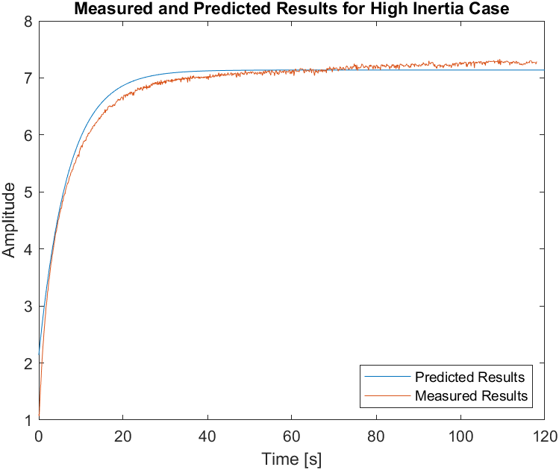

Figure 7: Measured vs Predicted results for high inertia plant condition

It is observed that transfer functions obtained via system identification match measured results with fair accuracy.

# 4. Similar industrial applications

The system in the lab is a servo-motor system. Servo motors are devices that precisely rotate and push components of a mechanical machine. Servo motors are mainly used for angular/linear position control, as well as velocity and acceleration control. [1].

A good example of servo motors being used in industry are laser cutting machines. Servo are used in this application to compensate , optimise and coordinate the actions of various systems to a certain extent, to ensure better control of the system. [2]

Servo motors also find application in CNC machining. The servo motor converts a non-linear input into linear movement at the spindle shaft and table. The feedback of a servo motor ensures that there is always an exact positioning signal, which is beneficial in industrial applications where parts being created/cut need to be precise and uniform. [3]

Servo motors also find application in the textile industry. Servos are used in tension control in spinning and weaving machines, and work by applying electronic let off and electronic take up techniques. [4]

# References:

[1] Fujielectric.com. 2022. *The Purpose of Servo Motors | Fuji Electric Product Column | Fuji Electric Global*. [online] Available at: <https://www.fujielectric.com/products/column/servo/servo_01.html> [Accessed 16 March 2022].

[2]En.finepower-tech.com. 2022. [online] Available at: <http://en.finepower-tech.com/case_view.aspx?nid=4&typeid=29&id=479> [Accessed 16 March 2022].

[3] “Servo Motors for CNC Machines,” *HEIDENHAIN*, Apr. 22, 2019. https://www.heidenhain.us/resources-and-news/servo-motors-for-cnc-machines/#:~:text=The%20two%20motors%20most%20often.

[4] . C. Gheewala, H. Jariwala, and P. C. Gheewala, “Tension control by servo motor in textile application using electronic let off and electronic take up technique,” *IEEE Xplore*, Aug. 01, 2017. https://ieeexplore.ieee.org/document/8390212 (accessed Mar. 16, 2022).